**Proposal of Method Design of Release/Retention Rate for Pyriproxyfen Matrix Release Formulation**

Makiko Mukumoto

Sumitomo Chemical Co., Ltd.

I. Introduction

Dengue fever is a mosquito-borne infection which in recent years has become a major international public health concern. Dengue viruses are transmitted to humans through the bites of infective female *Aedes* mosquitos. Because they find breeding opportunities in small water collections in and around houses, it is effective and efficient to throw in an MR formulation into any containers used for storing water to control larvae of mosquito.

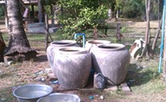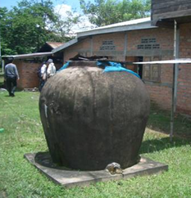

Figure 1 shows the summary of how to use MR formulations.

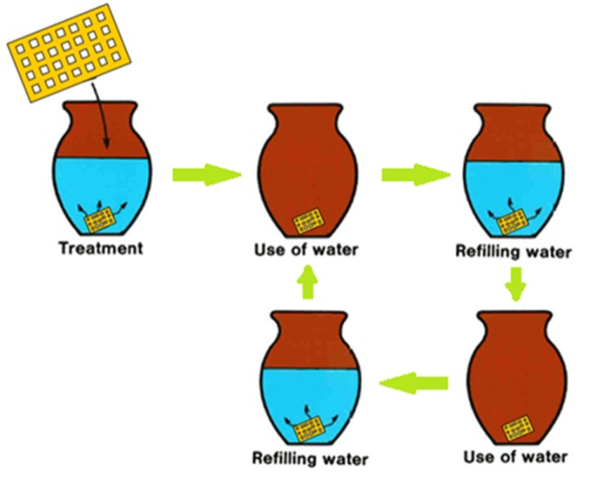

Figure 1 How to use MR formulations

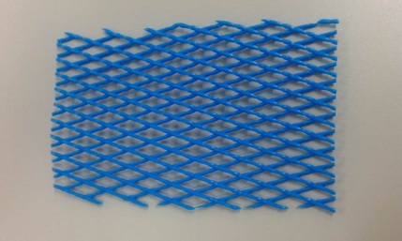MR formulations consist of one or more AIs, polymer and formulants. Manufacturing and loading of AIs of these polymer formulations is similar to LNs – incorporated or coated, but the application method is totally different.

MR formulations are ones which AIs are slowly released and provide long-lasting effectiveness.  Controlled and continuous release rates to water are very important to maintain efficacy. Therefore, release/retention rate is included in the specifications of MR formulations to ensure this long-lasting effectiveness.

The release/retention behaviours of AIs from MR formulations mainly depend on the external environment and the co-formulants (resin polymer) of the products. For example, the release/retention rate of AI depends on the water temperature, the types of polymers, its surface area of the product and so on. And, the maximum concentration of AI in water depends on its water solubility. Thus, it is considered that analytical methods of release/retention rate would be product-specific.

This report proposes our method design for release/retention rate of our MR formulation, pyriproxyfen MR.

II. Summary of Pyriproxyfen MR

AI: Pyriproxyfen (20 – 30 g/kg)

Type: Incorporated type

Water solubility of pyriproxyfen: 0.37 mg/L at 25°C and pH 6

Period efficacy: 6 months

III. Method Design of Release/Retention Rate

An analytical method for release/retention rate is desirable to be simple and informative model to describe release properties of a product. In addition, it is also preferable to be able to distinguish a good product from a bad one.

Based on these concepts, the following investigations were conducted.

1. Confirmation of AI movement in actual application

In actual application, one piece of Pyriproxyfen MR is applied into 40L of water. In order to know the AI movement in water and the MR formulation, the following experiment was conducted:

1. One piece of Pyriproxyfen MR was divided equally into five.
2. One of them (about 500 mg) was applied into 8L of water to prepare testing sample.
3. These testing samples were stored at 25°C.
4. Half volume of water of the testing samples was replaced with flesh water every week. And, the AI content in 200 mL of the removed water was determined every week. The remained AI content in MR formulation was calculated using the obtained AI content in water.

The AI movements in water and in MR formulation are shown in Figures 2 and 3. As a result, the AI content slowly decreased and it was about 1.6% after 24 weeks.

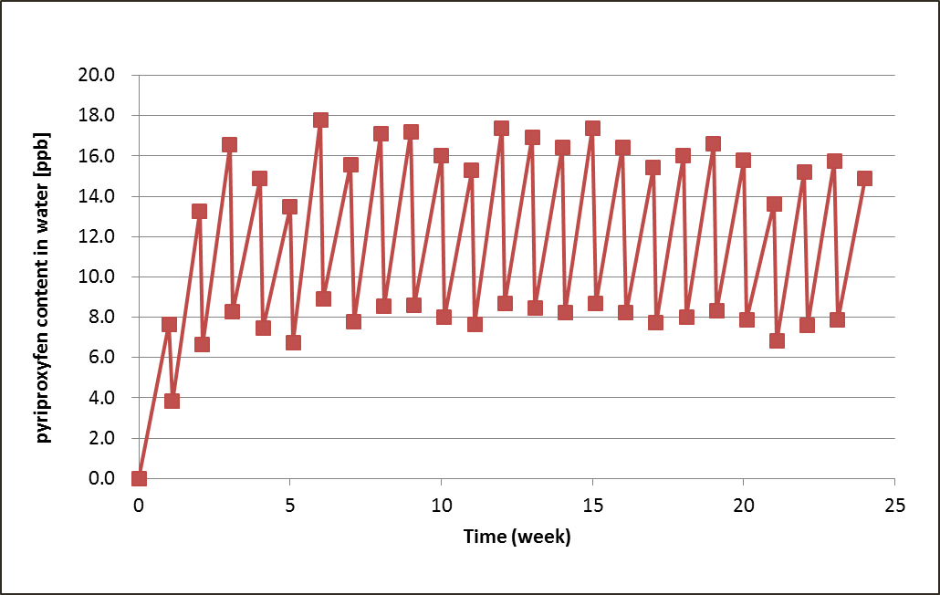

Figure 2 AI movement in water for 24 weeks

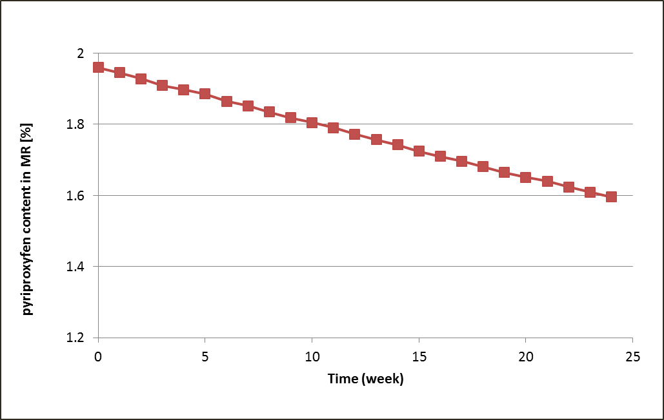

Figure 3 AI movement in MR formulation for 24 weeks

2. Design of test system

In order to evaluate the AI movement in shorter time, some accelerated test systems were investigated.

(1) Test system under heating

The following experiment was conducted:

1. About 60 mg of Pyriproxyfen MR was applied into 1L of water to prepare testing sample. Some testing samples were prepared in the same manner.
2. These testing samples were stored at 30°C and at 50°C, respectively.
3. The AI contents of MR formulations were determined over 8 weeks (50°C) and over 12 weeks (30°C).

The results are shown in Figure 4. No significant acceleration of release rate by heating was observed, and it took 8 weeks to decrease the AI content to 1.6% at 50°C. From these result, it was considered that the sufficient acceleration of release rate would not be possible in any test system using water as a solvent.

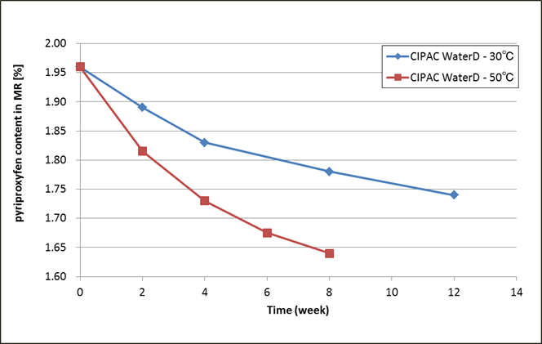

Figure 4 Comparison of AI movements at 30°C and at 50°C

(2) Test system using organic solvent

From the result of ‘(1) Test system under heating’, some test systems using organic solvents as a solvent were investigated. The solvents investigated were as follows:

a. 25% Ethanol/water b. 50% Ethanol/water

c. 25% Acetonitrile/water d. 50% Acetonitrile/water

e. 25% Acetone/water f. 50% Acetone/water

g. 25% Tetrahydrofuran (THF)/water h. 50% THF/water

The following experiment was conducted:

1. About 500 mg of Pyriproxyfen MR was applied into 50 mL of each solvent to prepare testing samples. Some testing samples were prepared in the same manner.
2. These testing samples were placed in a horizontal shaker in an upright position and shaken at 25 ± 5 °C at a frequency of 150 revolutions per minute (rpm) during the test.

3) The AI contents of MR formulations were determined after 2, 4 and 22 hours.

The results are shown in Figures 5 to 8. No significant accelerations of release rate by using all 25% mixed solvents were observed, and these AI contents 22 hours later were more than 1.6%. And, pyriproxyfen was released too quickly by using all 50% mixed solvents except for 50% ethanol/water. The AI content of MR formulation applied into 50% ethanol/water decreased more slowly than others applied into 50% mixed solvents, and it was about 1.6% after 4 hours. This AI movement for 4 hours was similar to that obtained from the test system using water at 50°C for 8 weeks.

From these results, it is concluded that 50% ethanol/water is reasonable as the extraction solvent and feasible to evaluate the release/retention rate of Pyriproxyfen MR in shorter time.

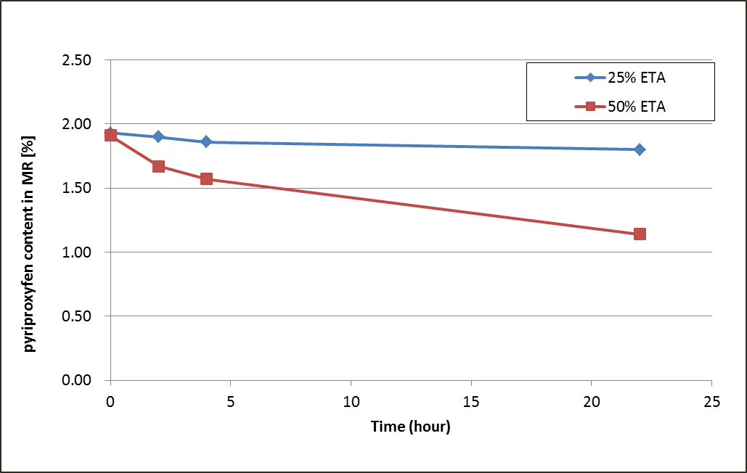

Figure 5 AI movement in testing system using Ethanol/Water

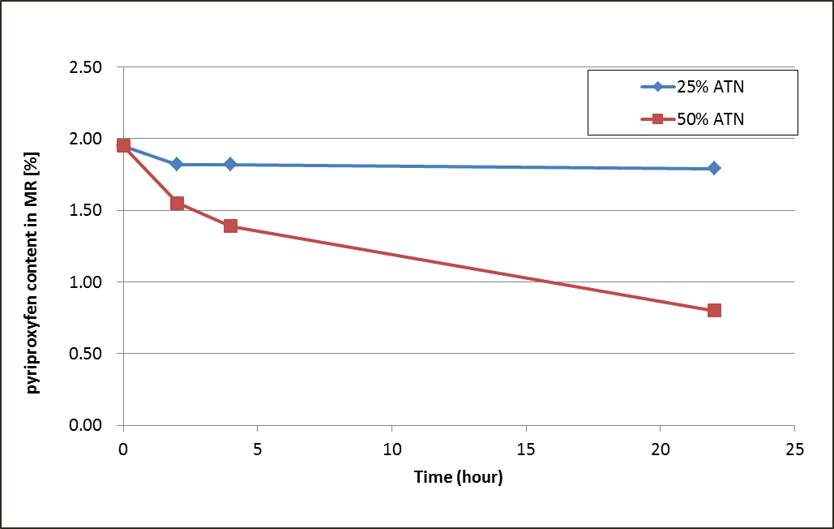

Figure 6 AI movement in testing system using Acetonitrile/Water

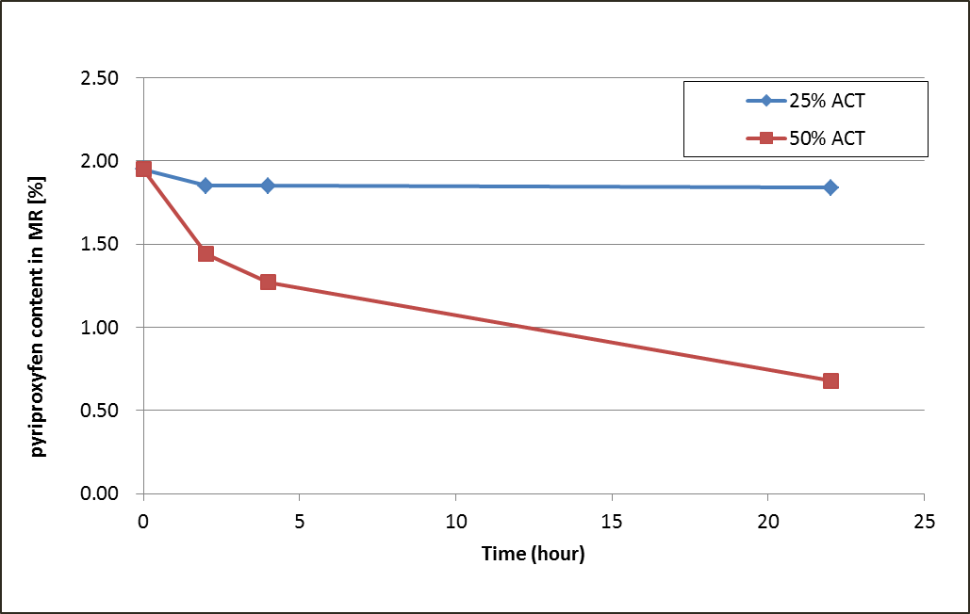

Figure 7 AI movement in testing system using Acetone/Water

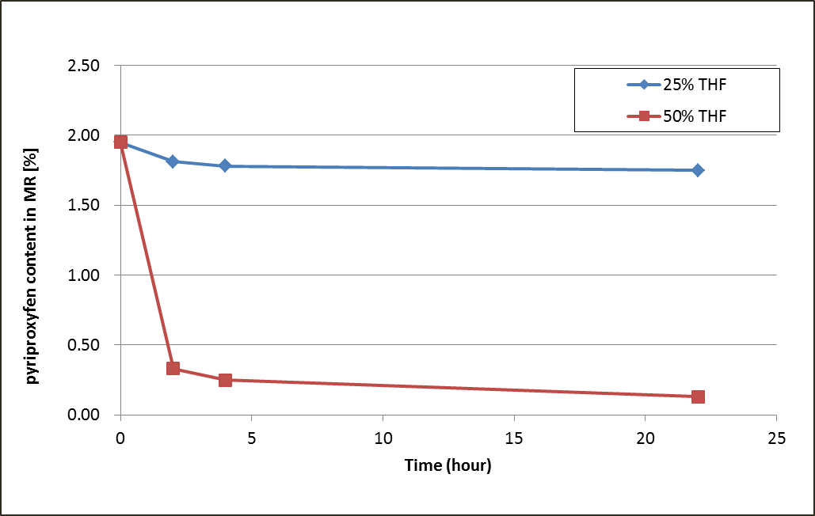

Figure 8 AI movement in testing system using THF/Water

(3) Capability to distinguish good MR from bad one

In order to check the capability of the test system using 50% ethanol/water, the AI movements using one good MR (Pyriproxyfen MR) and two bad MRs were compared. The bad MRs were ‘too quick release type (Bad MR-A)’ and ‘too slow release type (Bad MR-B)’.

This test was conducted by following two procedures:

Procedure-1 (Non-replenishment method);

1. About 500 mg of Pyriproxyfen MR was applied into 50 mL of 50% ethanol/water to prepare a testing sample. Six testing samples were prepared in the same manner.
2. These testing samples were placed in a horizontal shaker in an upright position and shaken at 25 ± 5 °C at a frequency of 150 rpm during the test.
3. The AI contents of MR formulations of two testing samples were determined after 1 hour (1-hour sample) and the average was calculated. Another 2 testing samples, after 2 hours (2-hour sample). And the last two testing samples, after 4 hours (4-hour sample).
4. Besides these testing samples, two non-treatment MR formulations were determined and the average was calculated (0-hour sample).
5. The release/retention rate was calculated using the following equation:

Release/retention rate (%) = A/B×100

A; AI content of 1, 2 or 4-hour sample

B; AI content of 0-hour sample

Procedure-2 (Replenishment method);

1. About 500 mg of Pyriproxyfen MR was applied into 50 mL of 50% ethanol/water to prepare a testing sample. Ten testing samples were prepared in the same manner.
2. These testing samples were placed in a horizontal shaker in an upright position and shaken at 25 ± 5 °C at a frequency of 150 rpm during the test.
3. The AI contents of MR formulations of two testing samples were determined after 0.5 hours and the average was calculated (0-replenishment sample).
4. Another 2 testing samples were removed from the bottles and replenished with fresh 50 mL of 50% ethanol/water into bottles after 0.5 hours. The AI contents of MR formulations from these two testing samples were determined after 1 hour and the average was calculated (1-replenishment sample).
5. Another 2 testing samples were removed from the bottles and replenished with fresh 50 mL of 50% ethanol/water into bottles after 0.5 and 1 hours. The AI contents of MR formulations from these two testing samples were determined after 1.5 hours and the average was calculated (2-replenishment sample).
6. Another 2 testing samples were removed from the bottles and replenished with fresh 50 mL of 50% ethanol/water into bottles after 0.5, 1 and 1.5 hours. The AI contents of MR formulations from these two testing samples were determined after 2 hours and the average was calculated (3-replenishment sample).
7. The last 2 testing samples were removed from the bottles and replenished with fresh 50 mL of 50% ethanol/water into bottles after 0.5, 1, 1.5 and 2 hours. The AI contents of MR formulations from these two testing samples were determined after 2.5 hours and the average was calculated (4-replenishment sample).
8. Besides these testing samples, two non-treatment MR formulations were determined and the average was calculated (0-hour sample).
9. The release/retention rate was calculated using the following equation:

Release/retention rate (%) = A/B×100

A; AI content of 3-replenishment sample or 4-replenishment sample

B; AI content of 0-hour sample

In both procedures, the AI movements obtained from the good MR and the bad MRs were clearly different (Figures 9 and 10). The release rates obtained from Procedure-1 was 86% (1-hour sample/0-hour sample), 83% (2-hour sample/0-hour sample) and 78% (4-hour sample/0-hour sample) respectively, and that obtained from Procedure-2 after 3 replenishments and 4 replenishments were 82% and 81% respectively.

From these results, it is confirmed that these test systems are able to distinguish a good product from a bad one.

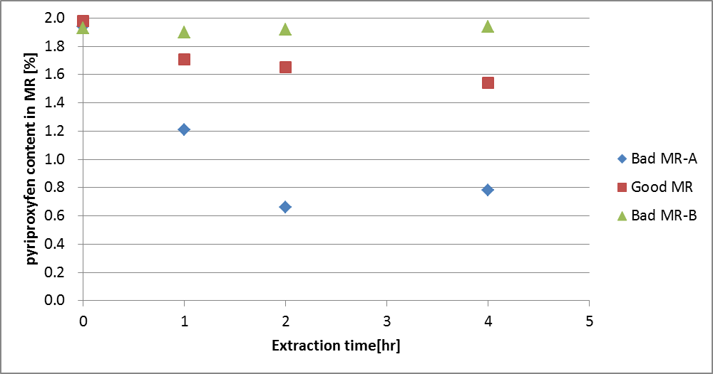

Figure 9 Comparison of AI movements of good and bad MRs (Procedure-1)

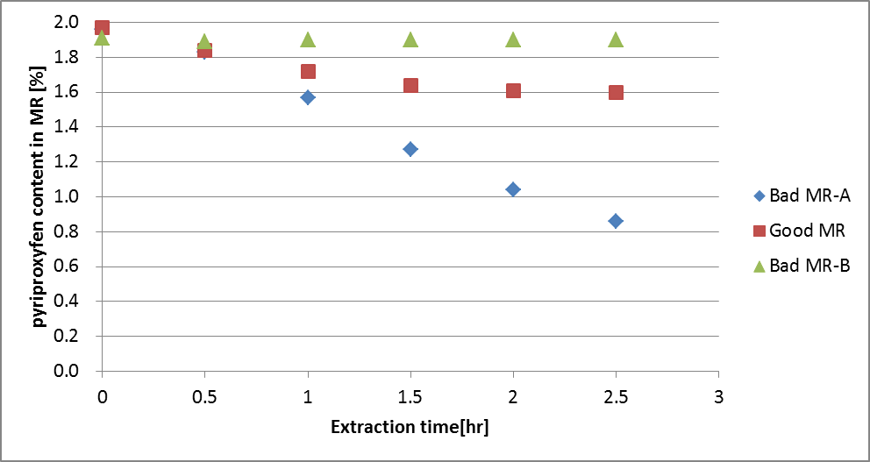

Figure 10 Comparison of AI movements of good and bad MRs (Procedure-2)

IV. Conclusion

Two methods for release/retention rate, ‘non-replenishment method’ and ‘replenishment method’, were designed. The summaries of these methods were shown in Appendix.

The former is simpler method but takes longer time. On the other hand, the latter is shorter method but requires more steps.

Based on the opinions obtained from CIPAC members, it will be modified and then a collaborative study will be conducted to establish its MT method.

**Appendix**

(Summaries of methods for release/retention rate of Pyriproxyfen MR)

I. Non-replenishment method

PROCEDURE

Clean a pair of scissors with acetone before use. Cut the sample with the scissors into pieces by about 500 mg. Prepare 12 pieces of samples.

Analyse 3 pieces of the samples for their pyriproxyfen content without accelerated extraction (0-hour sample).

Subject the remaining 9 pieces of samples to be eluted in 50 mL of 50% ethanol/water. Weigh (to the nearest mg) a cut sample and put it into a clean, dry screw capped bottle (100 – 150 ml). Add 50 ml of 50 % ethanol/water into the bottle and cap the bottle tightly. Place these bottles in a horizontal shaker in an upright position and shake at 25 ± 5 °C at a frequency of 150 revolutions per minute (rpm). After 1 hour, remove 3 bottles from the horizontal shaker and immediately pick up the MR sample using tweezers from each bottle removing any remaining adherent drops of fluid by gentle shaking.

Repeat this procedure after 2 hours and again after 4 hours. Analyse these MR samples for their pyriproxyfen content (1, 2 and 4-hour samples).

Calculate the release/retention rate at time ‘t’ using the following equation:

*Rt* = *Ct / C0*×*100 %*

where:

*Rt* = release/retention rate at time ‘t’ (%)

*t* = shaking time (hours)

*Ct* = total pyriproxyfen content (g/kg) retained at time ‘t’

This value is the mean total pyriproxyfen content of three samples.

*C0* = total pyriproxyfen content (g/kg) of 0-hour sample

This value is the mean total pyriproxyfen content of the 3 samples.

II. Replenishment method

PROCEDURE

Clean a pair of scissors with acetone before use. Cut the sample with the scissors into pieces by about 500 mg. Prepare 6 pieces of samples.

Analyse 3 pieces of the samples for their pyriproxyfen content without accelerated extraction (0-hour sample).

Subject the remaining 3 pieces of samples to be eluted in 50 mL of 50% ethanol/water. Weigh (to the nearest mg) a cut sample and put it into a clean, dry screw capped bottle (100 – 150 ml). Add 50 ml of 50 % ethanol/water into the bottle and cap the bottle tightly. Place these bottles in a horizontal shaker in an upright position and shake at 25 ± 5 °C at a frequency of 150 revolutions per minute (rpm).

After 0.5 hours, remove these bottles from the horizontal shaker and immediately pick up the MR sample using tweezers removing any remaining adherent drops of fluid by gentle shaking. Insert these MR samples into new bottles containing 50 mL of fresh 50% ethanol/water and shake again. Repeat these procedures after 1 and 1.5 hours. After 2 hours, analyse these MR samples for their pyriproxyfen content (3-replenishment sample).

Calculate the release/retention rate using the following equation:

*Rt* = *C3 / C0*×*100 %*

where:

*Rt* = release/retention rate

*C3* = total pyriproxyfen content (g/kg) of 3-replenishment sample

This value is the mean total pyriproxyfen content of three samples.

*C0* = total pyriproxyfen content (g/kg) of 0-hour sample

This value is the mean total pyriproxyfen content of three samples.